Individual Profile

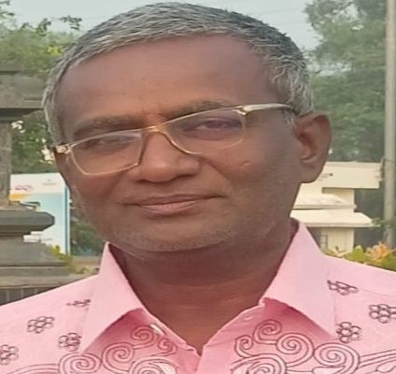

CURRICULUM VITAE

GELLI KODANDARAMULU

MOBILE : 8247393482
E-mail: kodanda1210@gmail.com

Career Objective:
Seeking a challenging position where my knowledge and skills can be best utilized in the successful completion of task assigned.

Academic Qualification:
QUALIFICATION | BOARD/  UNIVERSITY | COLLEGE/SCHOOL | YEAR OF PASSING
M.A , SLET | S.V.UNIVERSITY, TIRUPATHI | S.V.UNIVERSITY, TIRUPATHI | 1999
DEGREE | S.K.UNIVERSITY, ANANTHAPURAM | GOVT DEGREE COLLEGE (M),ANANTHAPUR | 1997
INTER | BOARD OF INTERMEDITER EDUCATION, A.P | GOVT JOUNIOR COLLEGE ,KANEKAL | 1992
S.S.C | AP STATE BOARD | ZP HIGH SCHOOL,MALYAM , ANANTHAPURAM DIST | 1990

Experience DETAILS:
- I have worked lecturer in K.T.S Govt degree college Rayadurg at 2000 - 2010
- I have worked lecturer in S.K.P Govt degree college GUNTAKAL at 2010- 16
- I have worked lecturer in Govt degree college Uravakonda at 2016 – 19
- I have Working lecturer in K.T.S Govt degree college at Rayadurg 2019- 25

PERSONAL DETAILS:

Father’s Name : G.VENKATARAMANAPPA
Mother’s name : G.SOBHAVATHAMMA
Gender : Male
Date of Birth : 10-12-19973
Nationality : Indian
Languages Known : Telugu, English, Kannada, Hindi
Address For Correspondence : G. KodandaRamulu
S/o G.Venkataramanappa
Do;-10/2/255/1 , opp SBI Bank,
Rayadurg, Anantapur (Dist).
Mobile : 8247393482.

